

**Software Architecture**

**SE205.3**

**Coursework**

**2023-2024**

**Group Assignment**

**Group Members**

|  |  |  |
| --- | --- | --- |
| **Index** | **Name** | **Degree** |
| 22851 | H.H Senavirathna | SE |
| 22863 | W.D Fernando | SE |
| 23863 | M.M.I.R.Chandrasiri | SE |
| 22809 | D.R.I.Alahakoon | CS |
| 22884 | K.A.U.U.D.S.Jayasekara | SE |

**Coursework Type:** Group Assignment

**Module Leader:** Dr. Rasika Ranaweera

Contents

Introduction to the 3D model 1

01. Customized and personalized products: 1

02. Sustainable manufacturing: 1

03. Space exploration: 1

04. Healthcare: 1

How Shape-Builders Work 3

03. Introduced Shapes 4

Tetrahedron 4

How do we think this will help the Blinds? 10

Used Structural design pattern. 11

Design Patterns 11

Design patterns used for the project. 11

Factory method implementation 12

Singleton implementation 15

MVC Implementation 17

OOP Concepts 19

Architectural diagrams 20

Class diagram 20

Use case diagram 21

Sequence diagram 21

Sample Pics 24

Home Page 24

Build Page 27

Customizing Shapes Page 28

Final Shapes Results 29

About Us Page 30

Group Members 31

Individual Contribution 32

Group member contribution summary 32

Conclusion 33

# Introduction to the 3D model

A 3D printer is a device that can build out physical objects one layer at a time from a digital model. Contrary to traditional manufacturing methods, which frequently require subtractive techniques like cutting, drilling, or milling, this procedure is known as additive manufacturing. The digital model of the thing is divided into layers for 3D printing, and the printer constructs the object by adding material layer by layer until it is finished.

Many types of 3D printers are available, each with unique features and capabilities. Some use filament-based extrusion techniques, while others use liquid resin or powder-based methods. They can print a wide variety of materials, including plastics, metals, ceramics, and even biological materials like living cells.

In the future, 3D printing is likely to have many exciting applications, some of which include:

## 01. Customized and personalized products:

With 3D printing, it's possible to create customized products tailored to specific needs or preferences. This could include customized medical implants, personalized clothing, and accessories, or unique home decor.

## 02. Sustainable manufacturing:

3D printing has the potential to reduce waste and energy consumption in manufacturing by allowing for more precise and efficient use of materials.

On-demand manufacturing: 3D printing could allow for on-demand manufacturing of parts and products, reducing the need for large inventories and supply chains.

## 03. Space exploration:

3D printing could be used to manufacture parts and tools on demand during space missions, reducing the need to transport large amounts of spare parts and supplies from Earth.

## 04. Healthcare:

3D printing has the potential to revolutionize healthcare by allowing for the creation of customized prosthetics, implants, and even organs and tissues.

In general, the potential for innovation and expansion in a variety of fields and applications makes the future of 3D printing intriguing.

A wonderful way to make digital content more accessible to those with visual impairments is to develop a technology that enables blind people to touch and feel 3D shapes. It is feasible to produce physical replicas of digital designs that may be touched and explored by those who are unable to see them on a screen with the aid of a 3D printer and 3D modelling software.

In order for blind individuals to grasp the tool's design better, it would be necessary to develop, and 3D print a variety of shapes, including geometric shapes, letters, numbers, and other objects. To make it simpler for those who are blind to recognize and explore the shapes, they could be sorted and placed in a particular order.

The gadget can be used by teachers, parents, or anyone else who wishes to give blind people a hands-on introduction to shapes and patterns. Additionally, it could be utilized to assist visually impaired people in exploring and comprehending digital designs like engineering diagrams or architectural plans.

A wonderful strategy to encourage inclusivity and accessibility in design and education is to develop a tool that enables blind people to touch and feel 3D shapes.

# How Shape-Builders Work

The shape builder is a program that is made for the client to convert a 2D drawing into braille. This is done by taking the drawing and turning it into a 3D braille.

Firstly, the hardcopy of the picture is taken and the client or the artist himself converts the picture into a 3D model by using simple shapes like triangles, squares, circles, and ovals.

Basically, the application consists of two parts - the service and the client. The service is responsible for computing the dot amount or liquid required for the selected shape or Braille character, while the client provides the user interface for selecting the shape or text and entering the required parameters.

When the client application is launched, it retrieves the list of supported shapes and Braille characters from the service and gives a dropdown list with these options. The user can then select a shape or Braille character from the dropdown list and enter the required parameters.

When a standard shape is selected, the client sends a request to the service to retrieve the list of parameters for that shape, such as the radius and canter for a circle etc. The service then computes the perimeter of the shape based on the provided parameters and sends back the required dot amount to the client.

When the Braille option is selected, the client counts the number of dots required for the entered text and sends a request to the service with the dot count. The service then computes the required liquid amount based on the dot count and sends back the result to the client.

Both the client and service communicate with each other through HTTP/SOAP, following a predefined interface that specifies the methods and parameters that can be used for communication. This interface ensures that the client and service can interact seamlessly, regardless of the platform or language used to implement them.

# 03. Introduced Shapes

## Tetrahedron

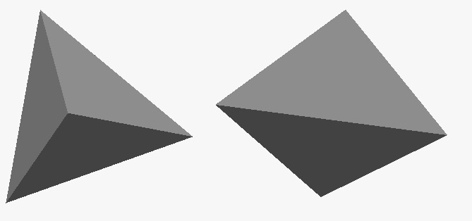

The tetrahedron is one kind of pyramid, which is a polyhedron with a flat polygon base and triangular faces connecting the base to a common point. In the case of a tetrahedron, the base is a triangle (any of the four faces can be considered the base), so a tetrahedron is also known as a "triangular pyramid".

ID: 21563

02. Hexagonal prism

Since it has 8 faces, it is an octahedron. However, the term octahedron is primarily used to refer to the regular octahedron, which has eight triangular faces. Because of the ambiguity of the term octahedron and the hilarity of the various eight-sided figures, the term is rarely used without clarification.

ID: 22654

03. cone

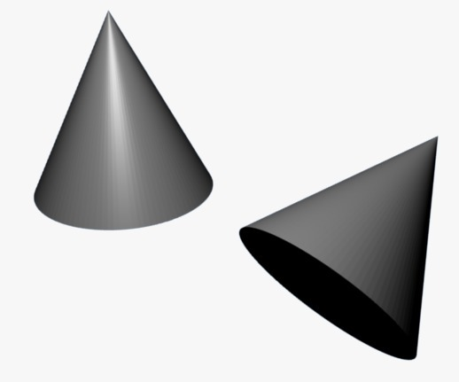

A cone is formed by a set of line segments, half-lines, or lines connecting a common point, the apex, to all the points on a base that is in a plane that does not contain the apex. Depending on the author, the base may be restricted to a circle, any one-dimensional quadratic form in the plane, any closed one-dimensional figure, or any of the above plus all the enclosed points. If the enclosed points are included in the base, the cone is a solid object; otherwise, it is a two-dimensional object in three-dimensional space. In the case of a solid object, the boundary formed by these lines or partial lines is called the lateral surface; if the lateral surface is unbounded, it is a conical surface.

ID: 12365

04. Cube

The cube is also a square parallelepiped, an equilateral cuboid, and a right rhombohedron a 3-zonohedron. It is a regular square prism in three orientations, and a trigonal trapezohedron in four orientations. The cube is dual to the octahedron. It has cubical or octahedral symmetry. The cube is the only convex polyhedron whose faces are all squares.

ID: 85697

05. Hexagonal Pyramid

A right regular pyramid is one which has a regular polygon as its base and whose apex is "above" the canter of the base, so that the apex, the centre of the base, and any other vertex form a right triangle.

ID: 45632

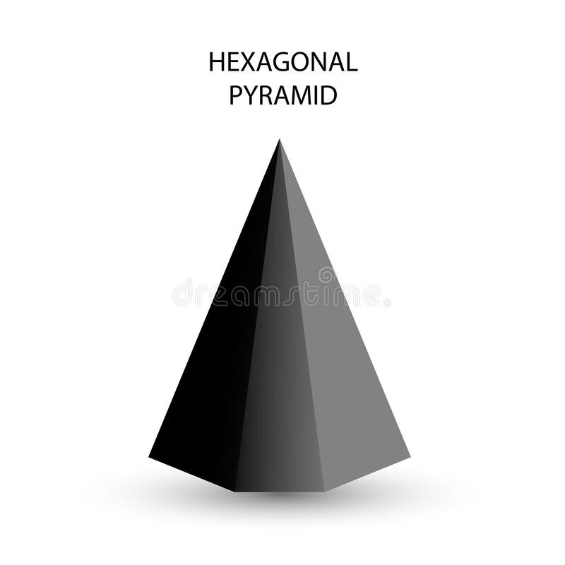

06. Sphere

A sphere is a fundamental object in many fields of mathematics. Spheres and nearly spherical shapes also appear in nature and industry. Bubbles such as soap bubbles take a spherical shape in equilibrium. The Earth is often approximated as a sphere in geography, and the celestial sphere is an important concept in astronomy. Manufactured items including pressure vessels and most curved mirrors and lenses are based on spheres. Spheres roll smoothly in any direction, so most balls used in sports and toys are spherical, as are ball bearings.

ID: 32564

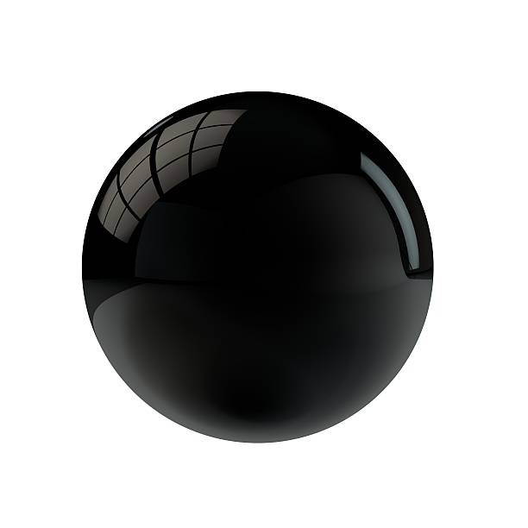

07. Icosahedron

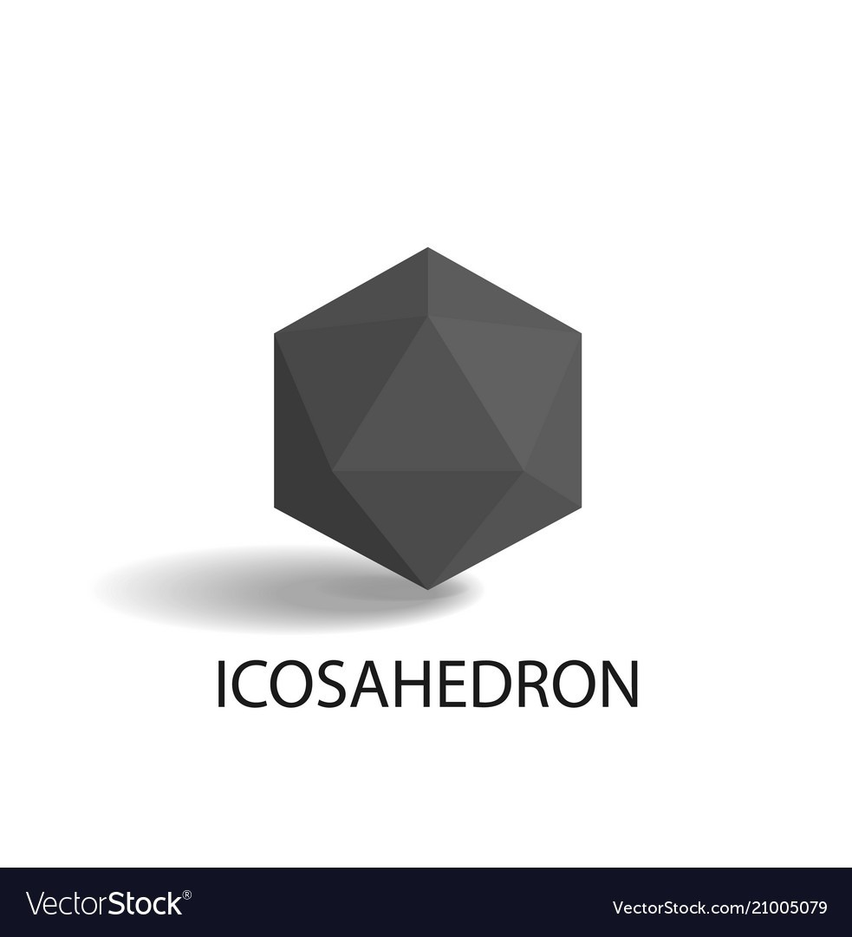

There are two objects, one convex and one nonconvex, that can both be called regular icosahedra. Each has 30 edges, and 20 equilateral triangle faces with five meeting at each of its twelve vertices. Both have icosahedral symmetry. The term "regular icosahedron" generally refers to the convex variety, while the nonconvex form is called a great icosahedron.

ID: 45962.

08. Cylinder

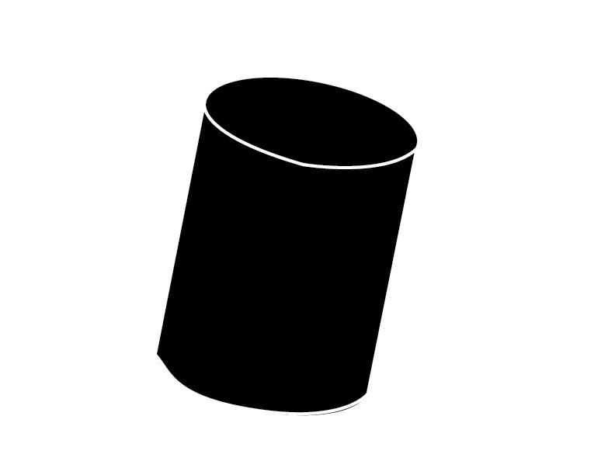

A cylindrical surface is a surface consisting of all the points on all the lines which are parallel to a given line and which pass through a fixed plane curve in a plane not parallel to the given line. Any line in this family of parallel lines is called an element of the cylindrical surface. From a kinematics point of view, given a plane curve, called the directrix, a cylindrical surface is that surface traced out by a line, called the generatrix, not in the plane of the directrix, moving parallel to itself and always passing through the directrix. Any position of the generatrix is an element of the cylindrical surface.

ID: 63945.

09. Triangular Prism

A right triangular prism is semiregular or, more generally, a uniform polyhedron if the base faces are equilateral triangles, and the other three faces are squares. It can be seen as a truncated trigonal holohedron, represented by the Schlafly symbol t {2,3}. Alternately it can be seen as the Cartesian product of a triangle and a line segment, and represented by the product, The dual of a triangular prism is a triangular bipyramid.

ID: 74193.

10. Pentagonal Prism

If the faces are all regular, the pentagonal prism is a semiregular polyhedron, more generally, a uniform polyhedron, and the third in an infinite set of prisms formed by square sides and two regular polygon caps. It can be seen as a truncated pentagonal holohedron, represented by the Schlafly symbol t {2,5}. Alternately it can be seen as the Cartesian product of a regular pentagon and a line segment and represented by the product {5} × {}. The dual of a pentagonal prism is a pentagonal bipyramid.

ID: 12345.

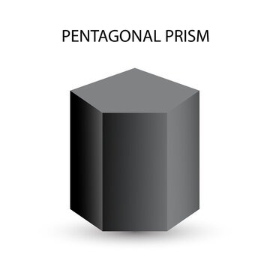

11. Dodecahedron

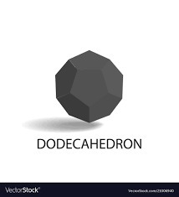

If the faces are all regular, the pentagonal prism is a semiregular polyhedron, more generally, a uniform polyhedron, and the third in an infinite set of prisms formed by square sides and two regular polygon caps. It can be seen as a truncated pentagonal holohedron, represented by the Schlafly symbol t {2,5}. Alternately it can be seen as the Cartesian product of a regular pentagon and a line segment and represented by the product {5} × {}. The dual of a pentagonal prism is a pentagonal bipyramid.

ID: 95137

12. Octahedron

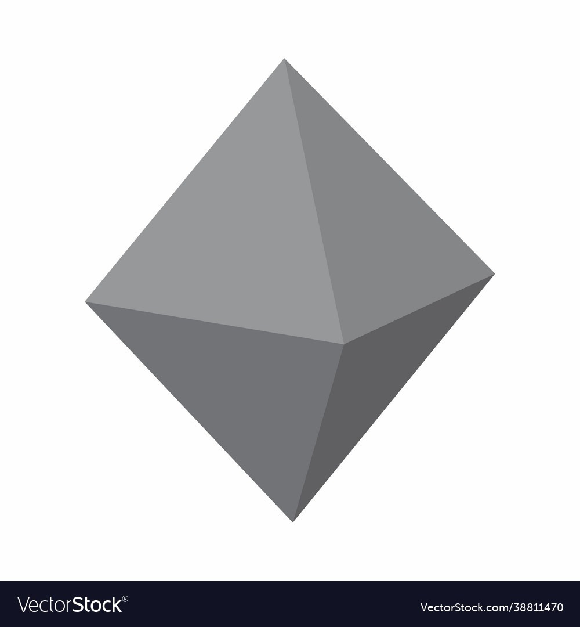

A regular octahedron is the dual polyhedron of a cube. It is a rectified tetrahedron. It is a square bipyramid in any of three orthogonal orientations. It is also a triangular antiprism in any of the four orientations.

ID: 45682.

13. Square Pyramid

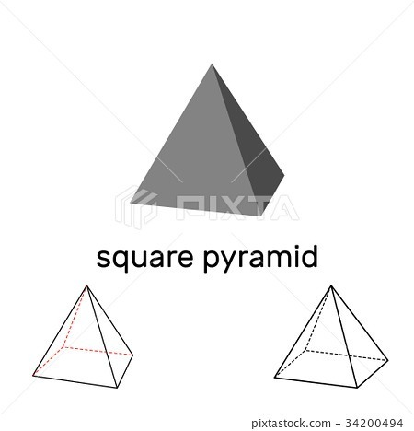

In a right square pyramid, all the lateral edges have the same length, and the sides other than the base are congruent isosceles triangles.

ID: 35755.

# How do we think this will help the Blinds?

This application is designed to provide a way for blind individuals to "see" and understand visual shapes through touch. The 3D printer used by the application will create tactile representations of the selected shapes, allowing the user to feel the shape and gain a better understanding of its properties.

Here are some key points on how this application can help the blind.

* This application is designed to provide a way for blind individuals to understand visual shapes through touch.
* The 3D printer used by the application will create tactile representations of the selected shapes.
* The application includes a Braille option that allows blind users to convert text to Braille and create a tactile representation of that text.
* The tactile representations created by the application can help blind users better understand and interact with visual content.
* By providing a way for blind individuals to "see" shapes and text through touch, this application can help improve accessibility and inclusivity for them.

Overall, this application can help improve the accessibility and inclusivity of visual content for blind individuals, allowing them to better understand and interact with shapes and text through touch.

# Used Structural design pattern.

## Design Patterns

Design patterns are essentially models or designs which can be used as guides when writing code. In a more formal way, design patterns can be described as “A proven solution to a common problem in a specified context”. Design patterns provide software developers with a toolkit for handling problems that have already been solved. The design pattern principles were applied to software design and architecture which were published in a book called “The Gang of Four” in 1994. Some of the design patterns in the book include.

* Abstract Factory
* Factory method
* Singleton
* Adapter
* Decorator
* Façade etc.

## Design patterns used for the project.

Although there are more than 20 design patterns available, each pattern is not suitable to use in every situation. To use a design pattern there should be a reason.

For this project, we used two design patterns to improve the functionality of the code and to enhance flexibility. The design patterns used,

* Factory method – Shape to Braille
* Singleton – Contact the 3D printer.
* MVC - convert text to braille

### Factory method implementation

1. First, an interface is created below.
2. Then we created an abstract class called shape
3. Then created the classes for respective all the shapes below is only the class Tetrahedron
4. Then the “shape Factory” class is created there create Shape method is implemented.
5. Finally, the web method calls the above methods from the shape factory class

### Singleton implementation

The idea was to access only by one person at a time increase the efficiency of the printer. To do that we used singleton design pattern.

1. Created a class which can connect with the printer and only by itself.
2. Then we created a private constructor which cannot be accessed by other outside classes.
3. Because of the private constructor implementation no outside classes can access this class. So we implement an instance which has thread safety using LAZY and READONLY keyword using this method no nested classes and threads can access the same class
4. Finally, we created a static getInstance method to give out access to the outside classes one at a time.

So using this method out access is possible. And no two classes can access the _3DPrinter at the same time.

### MVC Implementation

* We used MVC design pattern to implement the architectural pattern to get things done. In first we create folder design patterns like this
* The controller will get all the characters from the service
* Then the text is passed to the model
* And now the converted braille text is passed to the view method to create the view
* And then again the controller will get the result and display It to the user.

# OOP Concepts

* As per the codes above it is clear that the entire project uses OOP concepts. For example, in the Shape to Braille operation we have used abstraction, “I Shape” interface is an example of an abstraction that defines a set of necessary features that all shapes should have.
* Another one is Inheritance: The “Shape” abstract class is inherited by the general shapes classes and overrides its abstract methods.
* Polymorphism: The “Create Shape” method uses polymorphism which basically means having many forms. The “Create Shape” method uses the ‘type’ parameter to return different types of shapes.
* Encapsulation: The class “Shape Factory” encapsulate the logic for creating shapes and getting a list of available shapes, by making use of private methods and fields.

# Architectural diagrams

## Class diagram

## Use case diagram

## Sequence diagram

# Sample Pics

## Home Page

## Build Page

## Customizing Shapes Page

## Final Shapes Results

## About Us Page

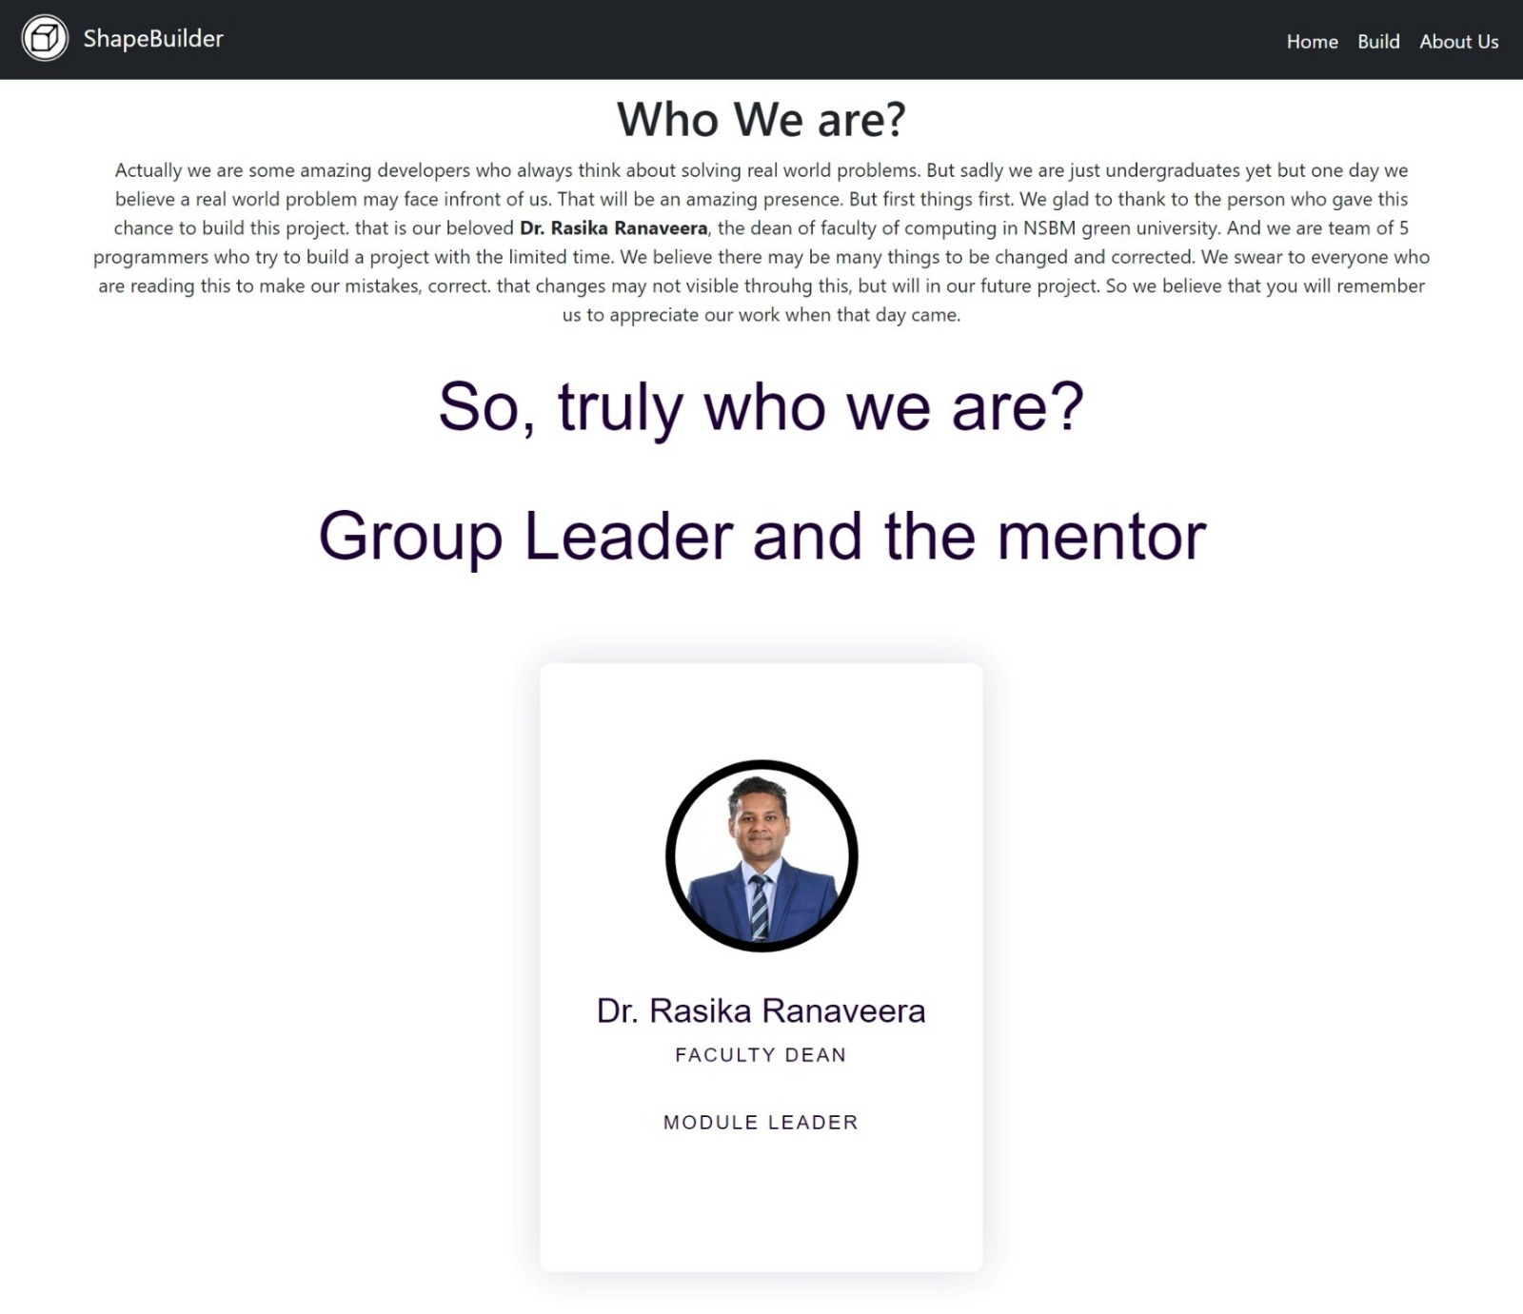

## Group Members

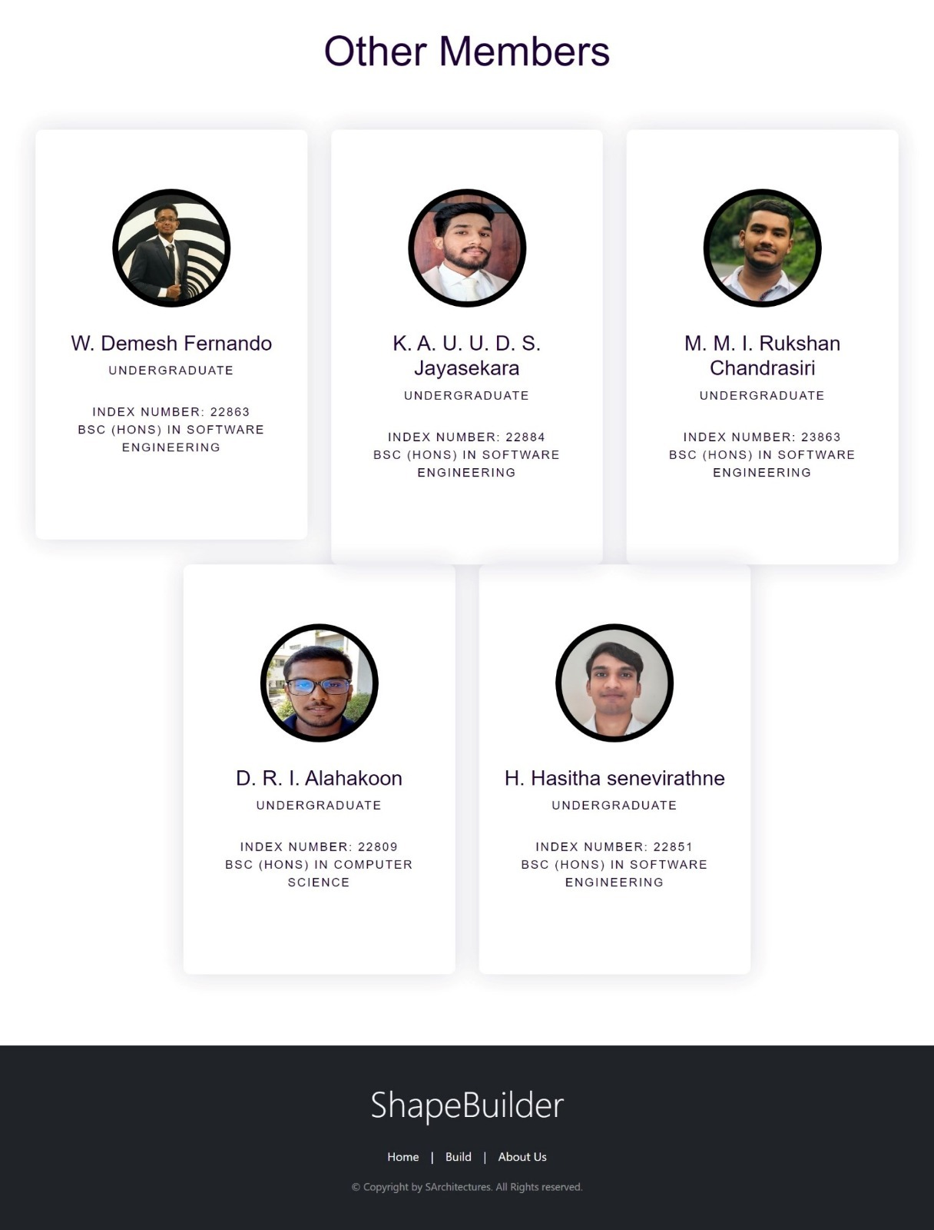

# Individual Contribution

|  |  |  |  |
| --- | --- | --- | --- |
| **Index** | **Name** | **Contribution** | **Percentage Contribution.** |
| 22851 | H.H. Senavirathne. | Contributed to Final Document Finalizing. | 20% |
| 22863 | W.D. Fernando. | Contributed to Frontend build | 20% |
| 23863 | M.M.I.R. Chandrasiri. | Contributed to Frontend build | 20% |
| 22884 | K.A.U.U.D.S. Jayasekara. | Contributed to Backend build | 20% |
| 22809 | D.R.I. Alahakoon. | Contributed to Backend build | 20% |

## Group member contribution summary

|  |  |
| --- | --- |
| **Name** | **Contribution Summary** |
| W.D Fernando. | Contributed to the Frontend build and using the singleton pattern. |
| M.M.I.R Chandrasiri. | Contributed to the Frontend build and using the singleton pattern. |
| D.R.I Alahakoon. | Contributed to the backend build and used the factory design pattern. |
| K.A.U.U.D.S Jayasekara. | Contributed to the backend build and used the factory design pattern. |
| H.H Senevirathne. | Contributed to the Final Document Finalizing process. |

# Conclusion

So, in conclusion,

A client is using the prototype app for the first time. They navigate through the user interface using a screen reader and select a circle shape from the drop-down list. The app prompts them to enter the radius and canter of the circle, which they do use a keyboard or other input device. The app then computes the required dot amount and sends it to the 3D printer.

The blind individual places their hand on the 3D-printed object/art and feels the tactile representation of the circle that has been created. They run their fingers along the raised outline of the circle, getting a sense of its shape and size. They can now visualize the circle through touch, which was previously not possible for them.

Next, the individual selects the Braille option and enters a short phrase. The app converts the text to Braille and computes the required liquid amount. The 3D printer then creates a tactile representation of the Braille text, allowing the blind individual to feel the dots and better understand the written content.

Overall, the client now can identify the functionality of the prototype app we created and the potential benefits it could provide. Now the blind can “see" visual shapes and written content through touch, which was previously not possible. They look forward to using the app to explore other shapes and texts in the future.